1. **Volunteer Recruitment:**

Volunteer recruitment is an essential module in hospital management. A registered user can apply for volunteer recruitment where he can add certain additional information which will get stored in the database. A volunteer can also upload his/her resume which will stored at a desired location. Uploading of resumes only accept document or pdfs and no other file type.

Admin can view volunteer details and can decide whether to accept or reject any volunteer. As soon as the admin changes the status, user gets a notification whether is accepted or rejected.

**ERD:**

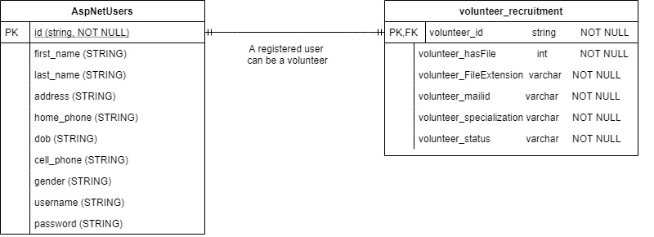

* One registered user can apply for volunteer recruitment and the primary key of AspnetUsers will be the foregin key of volunteer recruitment table.
* Note that all AspnetUsers are not volunteers. Primary key of AspNetUsers is a string which will store unique hash value.

**User story:**

John has decided to become a volunteer in the river side health care hospital. He visited the website and registered to become a valid user. Now, he has details of his account such as username, Email and password which is unique.

However, he is eligible to become a volunteer and he has his resume ready in word format. John visit the “Become a volunteer” link and he gets redirected to a new webpage where he is asked to fill some volunteer related details such as his mail id, any specialization in some work.

After filling out the form successfully, he will able to see the details i.e he will be redirected to show page of volunteer recruitment. In this page,he can update his details such as specialization or upload his resume. Clicking on update link he will be able to edit the specialization work or upload his resume which will be stored in database.

Uploading a resume doc or pdf will check that the file size is greater than 0 bytes and it will store by the id name as it will be easy to find and access it. Admin can view all the lisitng of the volunteers where he has the right to modify the status from Active to waiting or rejected or vice versa.

1. **Donation:**

Donation is useful feature in hospital website. For doing a donation, a user needs to register and submit his/her details. While registering, some of the user details must be submitted such as name, date of birth, email id.

The reason behind registration is that a donor don’t have to enter his personal details again and again. The user can just simply sign in and get to know how much he has donated till date and can donate more if he wants to. There are validations before making donations that user will enter only number in make donation text field. Specialization is text field where a user can specify any specific specialization he/she has.

**ERD:**

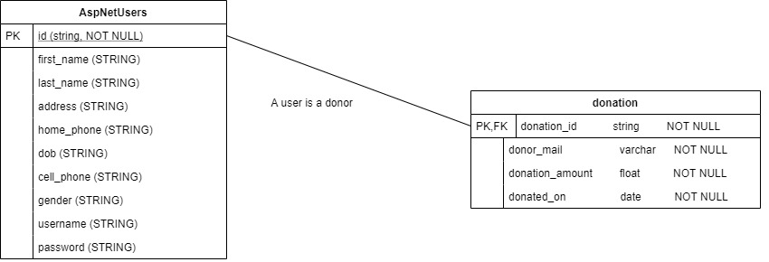

* One registered user can make donation and the primary key of AspnetUsers will be the foregin key of volunteer recruitment table.
* Note that all AspnetUsers are not donors. Also, Primary key of AspNetUsers is a string which will store unique hash value. Admin is handled by other member where admin role is to get list of all the donors.

**User Story:**

Michael wants to donate some amount in the Riverside Heath Care hospital. He visits the website and find on the donor link on the top right corner of the website. Michael clicks on the link and gets redirected to a Donation page form.

A form has certain details such as amount, email id for alternate contact which will reflect in the database. After filling out the form and submitting successfully, all the data will be stored in the database. Before storing into the database, there will validations done on the form. The entry in the database will be the user id, donated amount and the date on which donation took place.

Admin can list all the donors and can have a look how much donation is done by the all the users.

Admin can delete any donor details if he/she wants to. Updating is done by donor itself but only for certain fields such as email id. Donor can keep a track of how much he has donated just by signing up.